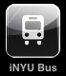**iNYU Bus Application Proposal**

by Andrei Oprisan

***Author***:   
Andrei Oprisan

***Project Title***:   
iNYU Bus

***Overview of the iPhone Application***:   
The purpose of the application is to help NYU students plan getting to and from their dorms and the Washington Square Campus. The application will automatically identify the date and time and will display all the relevant bus departure and arrival times based on the location preferences, as well as a master schedule list to be browsed for all the points of departure and arrival. Hopefully, the application will also provide both a static bus route map (to be browsed offline) and a GPS-aware Google map that will have the bus routes superimposed so that users can find the closest route based on their current location.

***Intended Audience***:   
NYU Washington Square students.

***Technical Challenges and Resources Needed***:   
1. The GPS-aware Google Map mashup with a scaled view of the NYU Bus routes on top will be, by far, the most challenging aspect of this application.

2. The entire application is built with an eye on implementing it for other schools’ bus systems, which has proven a bit challenging.

3. Bus schedule updates will not be necessary for NYU, since they remain static the entire year, which will result in new versions being released annually. This may not be the case at other schools, and I would like to implement this with a push-able SQlite database.

***Overall Logic, High-Level Flowchart, and Mockups***:   
4 Main Views:

* + - * **Next Ride:** Finds the next 2 bus departure and arrival times
      * **Schedule:**Shows the entire selected day’s schedule  to/from the selected destination
      * **Map:**Both statically drawn bus routes on a Manhattan man and a GPS Google Map mashup of bus routes

**About**  Purely informational, contains version and author information

4 Action Flows:

* + - * **Next Ride** -> Select Dorm -> Select Destination

**Results**: Next 2 Departure and Arrival Times, and Route Information

**Schedule** -> Select Dorm -> Select Destination -> Select Day of Week

**Results**: Table View of all Departure and Arrival Times for the Selected Day

**Map** -> Select Type (Static/Dynamic) (Dynamic requires iPhone 3.0)

**Results**: *Static* - Scalable Image Render of All NYU Bus Routes

*Dynamic* - Scalable Google Map Mashup of Current Location and All NYU Bus Routes

**About**

**Results**: Version and Author Information Screen

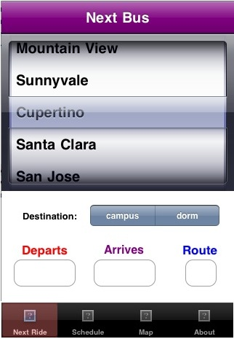

***Projected Features to be Implemented by May 4th***:   
All features (minus possibly the Google Maps mashup)  
will be implemented.

***Additional Features to be Implemented in the   
coming months***:   
If not implemented by May 4th, the Google Maps   
mashup will be implemented in the coming months.   
Also, a SQlite database should be implemented   
so that the application checks with each run if   
there is a new bus schedule available, and also  
uses the push notification service, and if so,   
load it from the server, then store it inside  
the application.